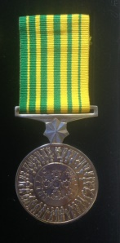
SA PSMA MEMBERSHIP APPLICATION FORM

Name: ........................................................................................................................................

Partner’s Name: ......................................................................................................................

Address: .....................................................................................................................................

......................................................... ...............................................................................................

Mobile: ........................................................................................................................................

Work Email: ........................................................………………………..……………………

Home Email: ........................................................…………………………………………….

  - Membership fee – currently $25 per annum.

  - Payment by direct bank transfer is preferable. Our banking details are:

Account name: SA Public Service Medal Association
BSB: 805 050 Account Number: 4104701.

  - Make sure to include your name in the description box so we know who has paid. The first year of membership is free, so await receipt of an invoice before paying.

Please return the completed form to the Secretary to:

Greg Parker PSM
E: gjpar1952@gmail.com
M: 0401 990 441

